TASK SHEET
Year: 12 General English
Topic: Responding to documentary Task 9

Topic:

Student: Teacher: Date Due: Term 3

Achievement Standards:
Receptive Modes: (reading, writing, viewing)
Productive Modes: (writing, creating)
Achievement Standard focused on:
- Viewing and writing
Time allocation: 3 periods
Conditions: In class development and creation of a feature article
At home research on a relevant topic

Weighting: 5%

Mark: _____/ 30

Teacher Comment:

Task
You will read and view a range of texts presenting ideas about health. You will consider the perspectives offered and examine how written and visual language is used to appeal to audiences. The main text is That Sugar Film, created and directed by Damon Gameau, which won Australian documentary of the year in 2015.
The key concepts and understandings of this section of work are about how texts present attitudes and assumptions, and how language is used to engage audiences. The ideas and understandings in this section of work will form part of the basis for the following task, Task 10: Group Health Campaign.
This task includes the following sections:
- ‘Before Viewing’ discussion activities: Class activities and discussion should give an engagement with the ideas in the documentary, and an understanding of how they are constructed and communicated. Complete all worksheets and activities
- ‘During Viewing’ directed notes: You should view the documentary and complete the short answers and responses.
- After viewing - evaluation of the documentary: Answer the questions about the effectiveness of the documentary, supporting your evaluation with references to the text.
- Analytical responses: View a section of the film and complete responses in class to explain specific uses of techniques and effects.

Self-reflection
What three things did I do well?
What three things could I have done better?
What things could I do in class to help me improve for the next task?
What things could I do at home to help me improve for the next task?

Section completion
Before viewing discussion notes
Limited -1 | 2 | 3 | 4 | Excellent -5
During viewing directed responses
Limited -1 | 2 | 3 | 4 | Excellent -5
After viewing critical responses
Limited -1 | 2 | 3 | 4 | Excellent -5
In class analytical responses
Limited -1 | 2 | 3 | 4 | Excellent -5
Total ___/20
Responding to Documentary
Engagement with the questions
Thoroughness and thoughtfulness of engagement with the questions and activities
Limited -1 | 2 | 3 | 4 | Excellent -5
Consideration of how attitudes and assumptions are presented in texts
Perception of different assumptions and attitudes in texts; identification of documentary codes and conventions
Limited -1 | 2 | 3 | 4 | Excellent -5
Understanding of the ways ideas and information are presented in texts
Identification of text structures and language features, and effects
Limited -1 | 2 | 3 | 4 | Excellent -5
Synthesis and collation of ideas and information
Explanation of evaluation, development and detail of responses, relevance of supporting arguments and evidence
Limited -1 | 2 | 3 | 4 | Excellent -5
Total: /20
Test: /20

In class short answer section

Working time for the task:

Preparation and Viewing: 10 minutes.

Read the paper, view the text. Students may take notes during this time.
Working: 50 minutes

Total marks: Marked out of 30 One section of Task 9

View the opening of the documentary That Sugar Film (0 – 3:15). May view twice. Questions 1 – 6 are about this part of the film specifically.

Question 7 asks you to annotate two still images from the film and explain their main ideas.

Questions 8 and 9 ask you to give evaluative answers.

The marks for each question are given in brackets.

Opening shot of cane fields: Identify
(a) the type of shot,

(b) camera movement used and
(c) what is being emphasised. (3 marks)

a)______________________________________________________________________________

b)______________________________________________________________________________

c)______________________________________________________________________________

________________________________________________________________________________

________________________________________________________________________________

Lyrics: Quote two lines from the opening song lyrics and explain their meaning with regard to the film’s message. (4 marks)

Line 1__________________________________________________________________________

________________________________________________________________________________

________________________________________________________________________________

Line 2___________________________________________________________________________

________________________________________________________________________________

________________________________________________________________________________

Identify two key attitudes Damon Gameau shows in the opening voice over. (2 marks)

________________________________________________________________________________

________________________________________________________________________________

________________________________________________________________________________

________________________________________________________________________________

________________________________________________________________________________

________________________________________________________________________________

Explain the symbolism of the scene with the family eating ‘breakfast’. (3 marks)

________________________________________________________________________________

________________________________________________________________________________

________________________________________________________________________________

________________________________________________________________________________

________________________________________________________________________________

________________________________________________________________________________

Describe how the opening segment uses shots of screens. Why do you think this is done? (2 marks)

________________________________________________________________________________

________________________________________________________________________________

________________________________________________________________________________

________________________________________________________________________________

________________________________________________________________________________

________________________________________________________________________________

Explain the meaning of the opening montage sequence of sweets and lollies. (2 marks)

________________________________________________________________________________

________________________________________________________________________________

________________________________________________________________________________

________________________________________________________________________________

________________________________________________________________________________

________________________________________________________________________________

Annotate the following two images, identifying the visual conventions used. Explain the main ideas in each image. (4 marks each)

Image 1

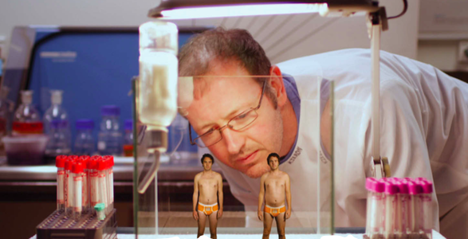

Main ideas:

________________________________________________________________________________

________________________________________________________________________________

________________________________________________________________________________

________________________________________________________________________________

________________________________________________________________________________

________________________________________________________________________________________________________________________________________________________________

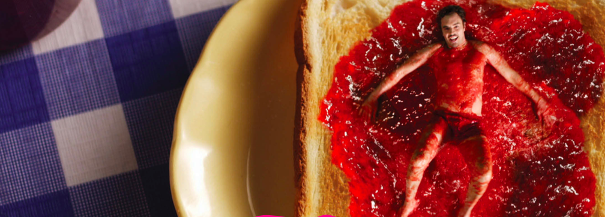
Image 2

Main ideas:

________________________________________________________________________________

________________________________________________________________________________

________________________________________________________________________________

______________________________________________________________________________________________________________________________________________________________________________________________________________________________________________

Explain some of the reasons why, although his experience in the film is interesting and informative, Gameau’s personal food challenge can’t be considered ‘scientific research’. (2 marks)

________________________________________________________________________________

________________________________________________________________________________

________________________________________________________________________________

________________________________________________________________________________

________________________________________________________________________________

________________________________________________________________________________

________________________________________________________________________________

________________________________________________________________________________

________________________________________________________________________________

________________________________________________________________________________

________________________________________________________________________________

_______________________________________________________________________________________________________________________________________________________________

________________________________________________________________________________

________________________________________________________________________________

________________________________________________________________________________

________________________________________________________________________________

________________________________________________________________________________

Explain your own evaluation of the film, giving relevant evidence to support your ideas. (4 marks)

________________________________________________________________________________

________________________________________________________________________________

________________________________________________________________________________

________________________________________________________________________________

________________________________________________________________________________

________________________________________________________________________________

________________________________________________________________________________

________________________________________________________________________________

________________________________________________________________________________

________________________________________________________________________________

________________________________________________________________________________

________________________________________________________________________________

________________________________________________________________________________

________________________________________________________________________________

________________________________________________________________________________

________________________________________________________________________________

________________________________________________________________________________

________________________________________________________________________________

Test Total: ____/30

Converted to ____/20

